|  |  |
| --- | --- |
| **First Grade** | |
| 2 marble composition notebooks  1 one subject spiral notebook  8 glue sticks  1 pair of scissors  2 boxes of crayons  3 packs of #2 pencils  1 soft zippered pouch for supplies (**No hard boxes**)  2 plastic folders (1 **green**, 1 **yellow**) | **Donations**  tissues  quart size bags (Last name A-L)  gallon size bags (Last name M-Z)  hand sanitizer (12oz. or larger) |
| **Second Grade** | |
| 3 composition black/white notebooks  8 glue sticks  2 boxes of pencils  4 folders  1 scissors  1 box of 24 crayons  Zipper pouch  1 pack of sticky notes  1 art smock  1 pack of index cards  2 pink erasers | **Donations**  tissues  Re-sealable plastic bags gallon & sandwich size  Hand sanitizer  Stickers |
| **Third Grade** | |
| Markers or crayons  3 black and white composition notebooks  10 #2 pencils (no mechanical pencils)  2 glue sticks or 1 bottle of glue  1 art smock (old shirt)  5 pocket folders  1 pack of index cards  1 pair of scissors  1 pack of sticky notes  1 highlighter | **Donations**  Sandwich size baggies  Gallon size baggies  Tissues  Paper towels  Bottle of hand sanitizer (12 oz or larger) |

|  |  |
| --- | --- |
| **Fourth Grade** | |
| 1 2-inch, 3-ring binder, (**NO BINDERS WITH ZIPPERS**)  3 2-pocket folders with brads  3 packs of lined notebook paper (wide-ruled)  1 pack of dividers (5 sections)  2 marble composition or spiral notebooks  1 zipper pencil case (**NO BOXES**)  1 3-hole punch that fits in a notebook  1 ruler with both inches and centimeters  1 pack of #2 pencils (**NO MECHANICAL PENCILS**)  1 box of colored pencils or crayons  1 pair of safety scissors  3 glue sticks  1 pack of pencil erasers  1 art smock or old shirt | **Donations**  tissues  re-sealable plastic baggies  hand sanitizer  sticky notes  pack of index cards |
| **Fifth Grade** | |
| #2 pencils (NO MECHANICAL PENCILS)  Colored pencils/crayons  Scissors  Glue stick  2 composition notebook  1 red two-pocket plastic folder  1 protractor (please keep home until requested)  Binder (at least 2”) ***No Trapper Keepers  Notebook paper (wide-ruled)  Zipper pencil case for binder  2 highlighters  A pack of 1 ½” x 2” sticky notes  Thesaurus (student edition)  (Dictionary (for home use)  10 section dividers  Art smock (old t-shirt)  Dual edged ruler (inches/centimeters) | **Donations**  Hand sanitizer  1 pack of 3”x 5” index cards with file box  gallon size baggies  sandwich size baggies  Tissues |
| **ALS** | |
| 2 marble composition notebooks  8 glue sticks  2 boxes of crayons  3 packs of #2 pencils  1 soft zipper pouch (no hard boxes)  3 plastic folders (1 red, 1 yellow, 1 green)  2 one-subject spiral notebooks  2 highlighters  1 pack (100) 3x5 index cards | **Donations**  Tissues  Paper towels  Hand sanitizer  Re-sealable plastic bags (a variety of sizes) |

**Kindergarten Supply List**

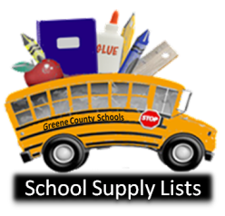**Mrs. Suman**

**Mrs. Cornish**

The following lists are supply items that will likely be needed by your child during the year.

* 1 backpack (This should be brought to school daily. No rolling backpacks, please.)
* 1 box of large crayons (eight basic colors)
* 1 box of washable markers (eight basic colors)
* 1 box of small crayons
* 4 jumbo pencils
* 3 black and white marble composition notebooks (no spirals please.)
* 2 pocket folders (vinyl or laminated folders will last longer.)
* 1 small blanket or towel for rest time (We provide a mat for each child.)
* 8 glue sticks
* 2 bottles of glue (4 ounces)
* 1 recent photograph of your child
* 1 complete change of clothes (The clothes will remain in your child’s locker in case of a spill or an accident.)

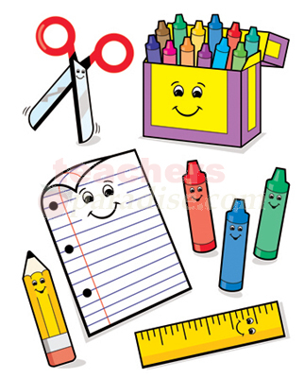

Families may donate the following school supplies:

* Tissues
* Hand sanitizer
* Large pencil erasers
* Zipper storage and sandwich bags
* Large sponges

NATURE10

Mrs. Greenberg’s Supply List

Kindergarten 2012-2013

Dear Families:

To help make your child’s Kindergarten adventure successful, the following supply items are requested:

1 backpack to be brought to school daily (no rolling backpacks please)

4 **beginner** pencils (the fat ones)

4 glue sticks

1 glue bottle (4 oz.)

3 black and white hardback composition books

2 pocket folders (**vinyl or laminated** ones last longer)

1 box of the 8 count **LARGE** size crayons (eight basic colors only please)

1 large towel for rest time (we will provide the mats)

1 large sponge (for wiping tables)

1 recent photo of your child

1 set of seasonally appropriate clothing to be kept in your child’s

locker in case of spill

*Please consider donating a box or two of tissues to the class.

\***No need to label the pencils, crayons, glue, sponges**.

\***Do label the backpack, folders, composition books, towel, clothing and photo**.

*Don’t forget home supplies. Make sure you have a place for your child to do

homework. Keep a pencil box at home with pencil, glue and crayons.

Come to our ***Kindergarten Meet and Greet***, **Friday, August 24** and get a sneak peek at our class.

Come to our “Back to School Night” in September to learn more about our Kindergarten day and to begin our parent-teacher partnership!

Check out my website,

<http://teachers.bcps.org/teachers_elem/sgreenberg2/home.html>

Contact me at by emailing, sgreenberg2@ bcps.org

ANIML062

Thank you in advance!